**Answers to Subjective Questions: Lead Scoring Case Study**

Submitted by:

Nishant Anand: nishantax2024@email.iimcal.ac.in

Nishant Gaurav: nishantgaurav@gmail.com

Parul Chopra: [parul6588@yahoo.co.in](mailto:parul6588@yahoo.co.in)

Group: DS71

1. Which are the top three variables in your model which contribute most towards the probability of a lead getting converted?

Answer: The top three variables in our model which contribute most towards the probability of a lead getting converted are:

|  |  |  |
| --- | --- | --- |
|  | **Features** | **Coefficient** |
| 1 | Total Time Spent on Website | 4.4862 |
| 2 | Variable: Lead Origin  Dummy variable: Lead Origin_Lead Add Form | 3.9719 |
| 3 | Variable: Last Notable Activity  Dummy variable: Last Notable Activity_Had a Phone Conversation | 3.5715 |

1. What are the top 3 categorical/dummy variables in the model which should be focused the most on in order to increase the probability of lead conversion?

Answer: The top 3 categorical/dummy variables in the model which should be focused the most on in order to increase the probability of lead conversion

|  |  |  |
| --- | --- | --- |
|  | **Features** | **Coefficient** |
| 1 | Lead Origin_Lead Add Form | 3.9719 |
| 2 | Last Notable Activity_Had a Phone Conversation | 3.5715 |
| 3 | What is your current occupation_Working Professional | 2.8135 |

1. X Education has a period of 2 months every year during which they hire some interns. The sales team, in particular, has around 10 interns allotted to them. So, during this phase, they wish to make the lead conversion more aggressive. So, they want almost all of the potential leads (i.e. the customers who have been predicted as 1 by the model) to be converted and hence, want to make phone calls to as much of such people as possible. Suggest a good strategy they should employ at this stage.

**Answer**: **Strategy for Aggressive Lead Conversion During the Intern Phase**

During the **2-month internship period**, X Education has **additional workforce (interns)** and wants to **maximize outreach to potential leads**. Since the goal is to **increase recall** (capture all potential conversions), here’s a structured approach:

1. **Lower the Classification Threshold:** By default, the model classifies leads as **converted (1)** if the predicted probability is **≥ 0.5**. Lowering this threshold will classify **more leads as potential conversions**, ensuring that the sales team **reaches out to more potential buyers**. By lowering the threshold to 0.33, recall in our case increased from 69.95% to 81.02% (train set) and 80.45% (test data). Since the recall rate is higher, **more leads get contacted.**

## **Prioritize High-Probability Leads**

F**ocus on leads with the highest probability of conversion should be done at first. To do this leads can be sorted based on predicted probability** (descending) and then they can be **called in batches**, starting with the highest probability group.

1. **Allocate Interns to Different Lead Segments**: **Interns can be divided into two groups:**

* **Follow-up on high probability leads through calling leads personally**: Leads with **probability > 0.6** → Immediate call by senior sales reps.
* **Engage medium-probability leads via email/text first:** Leads with **probability 0.35 - 0.6** → Send emails & SMS first before calling as a first step.

1. **Use SMS & Email Before Calling to Filter Responses**

* **Send an automated email/SMS** asking **if they are still interested**. Call only those **who respond positively**. This will **reduce wasted calls to uninterested leads and will Saves interns' time for more promising leads**
* **Extend Retargeting Efforts on social media:** For **leads that didn’t convert**, X Education can **run targeted ads** to **bring them back**. **Show dynamic retargeting ads on Facebook/Google** or **Offer limited-time discounts** during the intern period. **Personalize ads using course interests can also be shown to increase lead conversion.**
* Involving all platforms to attract maximum number of leads

1. Similarly, at times, the company reaches its target for a quarter before the deadline. During this time, the company wants the sales team to focus on some new work as well. So during this time, the company’s aim is to not make phone calls unless it’s extremely necessary, i.e. they want to minimize the rate of useless phone calls. Suggest a strategy they should employ at this stage.

**Answer**: When X Education reaches its **quarterly target early**, the goal is to **avoid unnecessary calls** and **focus only on the most promising leads**. In order to make only calls that are most necessary, the following strategy should be used:

## **Prioritize Hot Leads Only (Lead Score ≥ 80)**

* Focus **only on "Hot Leads" (Lead Score 80-100)**.
* Ignore **"Cold" (0-39) and "Mild" (40-59) leads**.

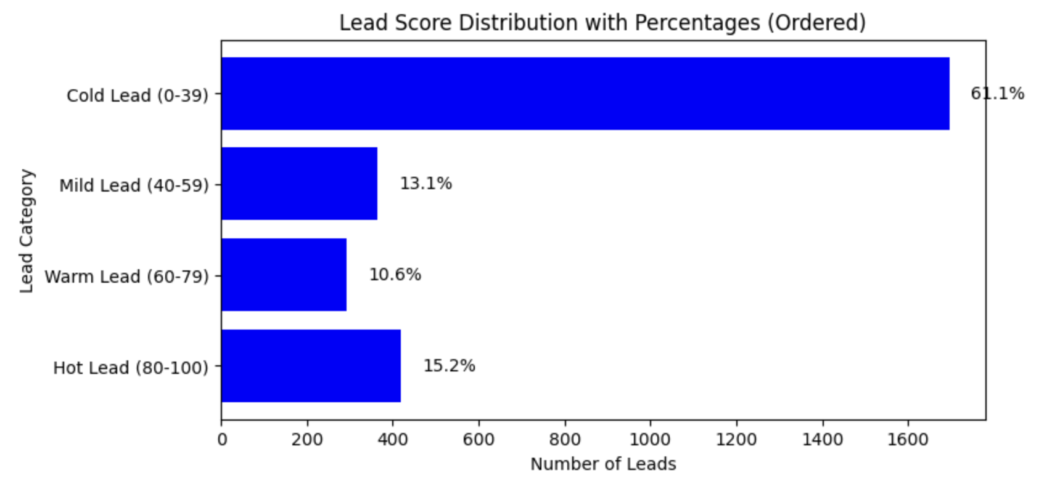

## **Introduce a Pre-Call Filter (Email/SMS Before Calling)**

* Instead of calling immediately, **send an SMS or email** asking for confirmation.
* Call only those **who express interest**.

#### **This Reduces unnecessary calls** helping **Sales team contacts only engaged leads**

* + - 1. **Top Model features should be used to plan a strategy:** Instead of using a **fixed threshold** the **machine learning model** can decide **which leads should receive a call** based on lead score and top selected features. Focus on increasing personalized content on the website and optimizing to increase average time spent, prioritize high-quality leads from the Lead Add Form, and follow up with phone calls for leads who’ve already had meaningful interactions in the past. Use AI to optimize call scheduling and reduce inefficiencies.
      2. **Explore Other Sales Tasks Instead of Calling:** Since the **sales team has free time**, they can **redirect efforts to:**
* **Re-engaging past leads** through targeted email campaigns.
* **Identifying trends** (which courses have highest demand and which field the person belongs to).
* **Upselling or cross-selling courses** to previous customers by follow up of interested leads.